Step-by-Step: Installing PCAnyWhere

Version: 12.0

| August-20 |

**Document Overview**

**Documentation Goals**

This documentation is intended to provide step by step instructions for ***installing the PCAnyWhere 12.0 application****.*

**Table of Contents**

**Installation Steps** 2

Insert CD 2

Run Installation Program 2

**Print Files During Remote Computer Session** 11

On Host Computer: 11

Remote Caller 11

Set Up Remote Computer Settings 11

# **Installation Steps**

## Insert CD

Place CD Rom in Drive. Depending on the user’s computer settings, it will either automatically run the program on the CD, or the user must run the CD program manually.

## Run Installation Program

### Step One: Main Screen

One the main program screen, the user must click the ***“Install Symantec PCAnywhere”*** option.

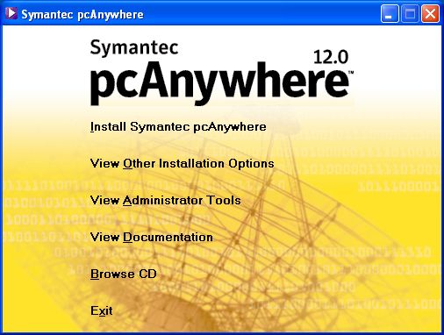

### Step Two:

The user will be prompted to enter information in the following dialogs:

#### Welcome Screen

Select the ***“Next”*** button at the bottom of the screen.

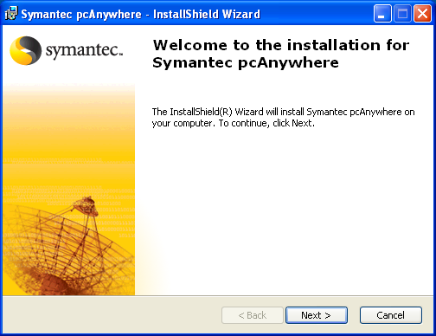

#### License Agreement

Make sure that the toggle box next to the ***“I accept the agreement”*** selection is filled in, then select the ***“Next”*** button at the bottom of the screen.

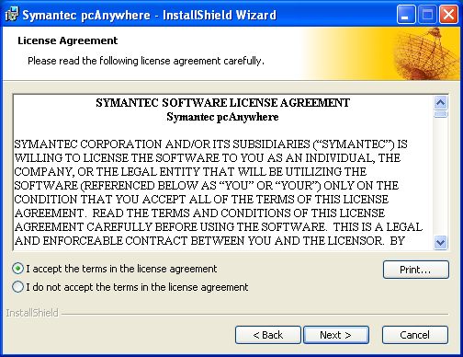

#### Customer Information

The user must enter their *User Name* and *Organization* name, then select the ***“Next”*** button at the bottom of the screen.

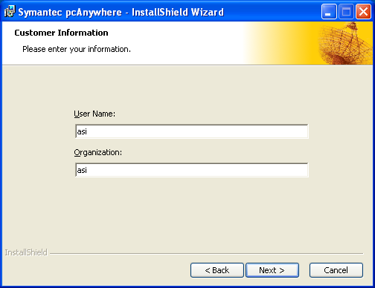

#### Destination Folder

The user should keep the default selections on this screen, and not attempt any changes. Then select the ***“Next”*** button at the bottom of the screen.

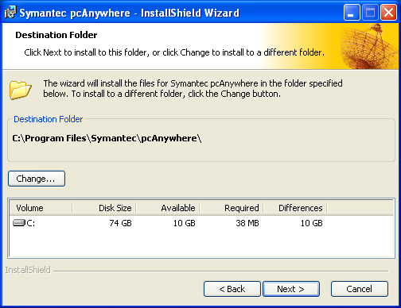

#### Custom Setup

The user should keep the default selections on this screen, and not attempt any changes. Then select the ***“Next”*** button at the bottom of the screen.

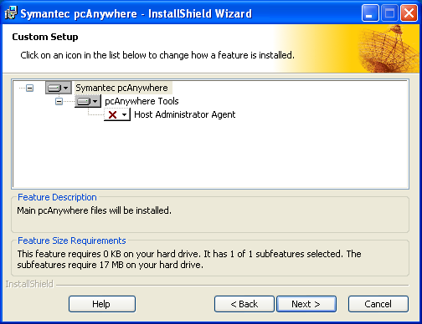

#### Ready to Install the Program

Select the ***“Install”*** button at the bottom of the screen.

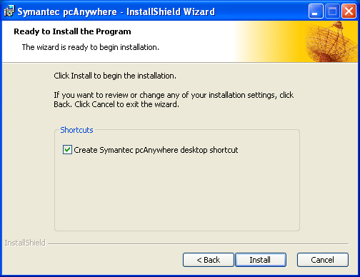

### Step Three: Setting Up for a Host Connection

#### Home Screen

Click on ***“Host”*** on the left side of the screen.

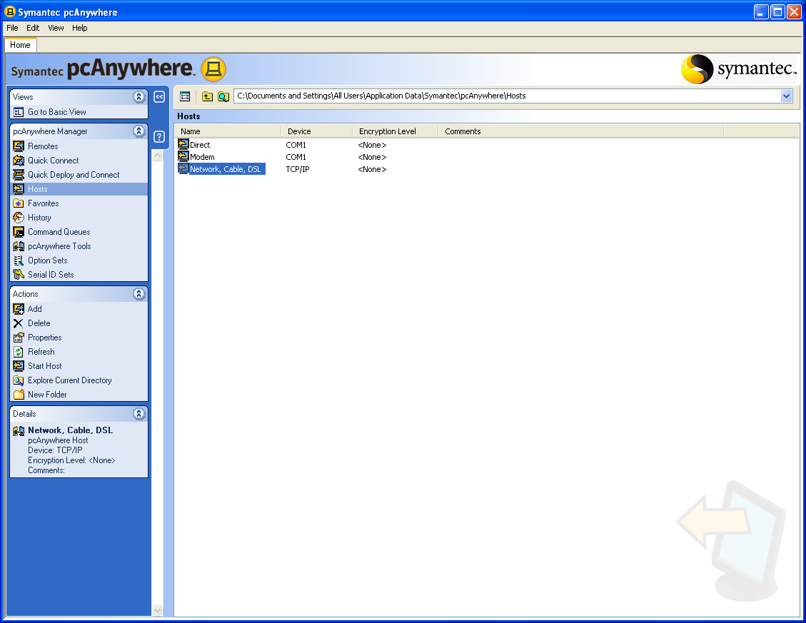

***“Right Mouse Click”*** on the *Network, Cable, DSL* Host.

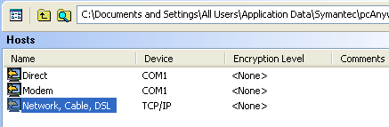

#### Host Properties: Network, Cable, DSL

Select the ***“Callers”*** tab at the top of the screen. Then, click on the ***“Paper Icon”*** on the left side of the screen in order to create a new item.

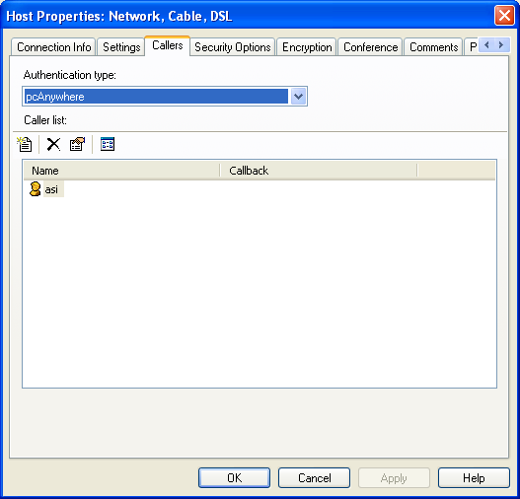

#### Caller Properties: New Caller

The user must enter a *Login Name* and *Password* for the new connection. This information comes from the Host computer. Then, the user should confirm the password, and select the ***“OK”*** button at the bottom of the screen.

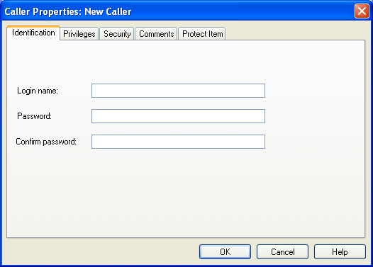

### Step Four: Connection Wizard

Setting up a Remote Connection to Another Computer using the Connection Wizard

#### Connection Method

Select the ***“Next”*** button at the bottom of the screen in order to make changes to the profile.

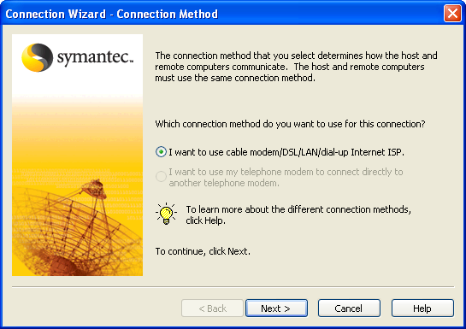

#### Destination Address

The user must enter the *IP Address* of the computer they will connect to, then select the ***“Next”*** button at the bottom of the screen.

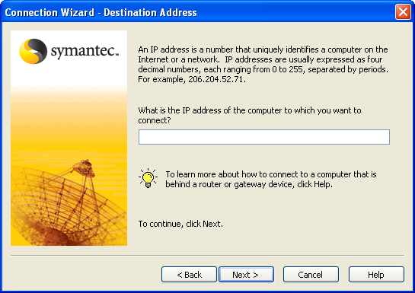

#### Summary Screen

The user should keep the default selections on this screen, and not attempt any changes. Then select the ***“Finish”*** button at the bottom of the screen.

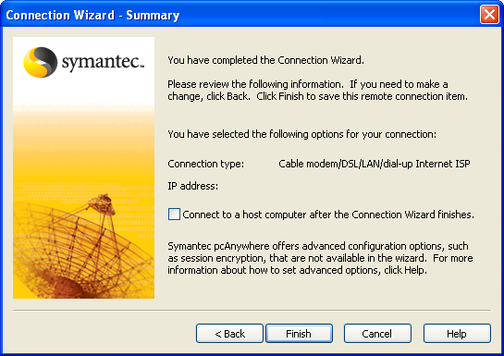

### Step Five: Remote Properties

Setting up a Remote Connection to Another Computer using properties of the icon.

The user should click on the ***“Icon”***, and go to *Properties*.

#### Icon Properties

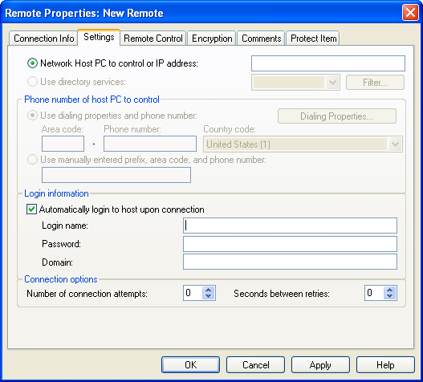

* Select the ***“Settings”*** tab at the top of the screen.
* The user should add the IP number of the computer they are connecting to.
* The user should ensure that the ‘*Automatically login to host upon connection’* toggle box is checked.
* The user must enter a *Login Name* and *Password* for the new connection.
* The user should enter a *Domain Name*, if it is applicable.
* Select the ***“Apply”*** button at the bottom of the screen.
* Select the ***“OK”*** button at the bottom of the screen.

### Step Six: Check Settings

The user should ***“Double-Click”*** the icon that they set up, and it should make connection to the Host computer if all the settings are correct.

Please Note: All the above information comes from the Host computer when setting up this screen on your computer.

# **Print Files During Remote Computer Session**

## On Host Computer:

#### Step One: Manager Window

In the *pcAnywhere Manager* window, click *Tools* > *Options*.

#### Step Two: Remote Printing Tab

On the *Remote Printing* tab, click ***Add Printer*** to add a remote printer definition to the list.

#### Step Three: Manufacturer List

In the *Manufacturers* list, click the remote computer’s printer manufacturer.

If the remote printer driver is not listed in the *Manufacturers* list box, install it following the printer manufacturer instructions. After installing the driver, it appears on the *Currently Installed Driver* list.

#### Step Four: Printer List

In the *Printers* list, click the remote computer printer model.

#### Step Five: Remote Printer Owner/Location

Type a name that identifies the owner or location of the remote printer.

#### Step Six: Finish Program

Click ***Finish***.

### Remote Caller

The remote caller selects this name to print to the local printer during a remote-control session.

If you want to print a file located on the host computer to a printer at your location during a remote-control session, you must specify your printer information in pcAnywhere. If you do not configure remote printing on your computer, your files are sent to the host computer’s default printer.

When adding a printer, you must have the correct drivers for the printer that you are using. pcAnywhere prompts you for the location of the printer, what port to use, and other configuration information.

## Set Up Remote Computer Settings

Set up a printer so the remote caller can print to the local printer during a session.

#### Select Printers

Select the printers on the remote computer that you want to print to during a remote-control session.

Please Note: The remote’s printer definitions must first be installed on the host computer using the Windows Control Panel.

To learn more about an option, ***“Right-Click”*** it, then click ***What’s This***.